Robert J. Paulsen
MicroAssist, Inc. Austin, TX
Texas FACT Clearinghouse
Technical Documentation
Contents
FACT Clearinghouse Overview 4
Common Workflows 4
New Applicant Gets Fingerprinted via FAST 4
Agency Subscribes to an Applicant 4
A Subscribed Applicant Has New Qualifying Event 4
Common Design Patterns 5
OPTION 1: Web-Only Access 5
OPTION 2: Local Storage of CHI 5
OPTION 3: Hybrid Solution 5
FACT Clearinghouse Diagram 6
Web Service Interface 7
Credentials and Other Prerequisites 7
Environments 7
Staging Environment 7
Production Environment 7
TLS 1.2 Requirement 7
TLS 1.2 in Windows/.NET 7
TLS 1.2 in Java 7
Trusted Store – Java 9
Export the certificate (See Screenshot): 9
Import the Certificate into the Java Cert Store: 9
Worklists 10
Worklist Descriptions 11
Worklist Descriptions (for FRB) 12
Worklist Contents 12
Worklist Contents (for FRB) 13
Applicants Moving Between Worklists 13
An applicant receives a qualifying event 13
Applicants on Multiple Worklists 14
Example 14
Web Service Examples 15
Example Agency/Service Interaction of New Applicants 15
Example Agency/Service Interaction of New Qualifying Events 16
Example C# Code 18
Example SOAP Message 19
Subscription Validations 20
FACT Clearinghouse Data Concepts 21
Changes to an Applicant Over Time 21
Closing an Applicant 22
Auto-Closing Applicants 23
Texas Criminal History Concepts 24
Consolidations 24
Searching for Consolidated SIDs 24
Impact to Subscriptions 24
FBI Rap Back (FRB) Subscriptions 26
Eligibility 26
A new applicant receives FRB 26
Rap Back Activity Notification (RBN) 27
FRB Data Elements 27
RBTED Data Elements 27
Rejected RBSCVL Transactions 27
Prevalidation 27
Consolidations 28
Data Formats 29
<WsClearinghouseRecord> Example 29
<WsCchResponseRecord> 30
GetRecord() “Format” Parameter 30
Use of <xsd:any> 30
Sample format=XML 31
Sample format=NIEM 31
Service Methods 32
Data Objects 35
WsWorklistSummaryItem 35
WsWorklistContainer 35
WsWorklistRecord 35
WsApplicantRecord 36
WsClearinghouseRecord 37
WsCchResponseRecord 37
WsFbiResponseRecord 37
WsSorResponseRecord 38
WsSubscriptionRecord 38
WsIdentifiers 38
Applicant Record Messages 40
Important Timeframes 41
Frequently Asked Questions 42
Q: When am I charged for viewing a record? 42
Glossary 44
Appendix A – Using SoapUI 46
Setup the WSDL 46
Configure the Endpoints 47
Setup WS-Security 48
Instruct the Method to use WS-Security 50
Execute the Method 50
Appendix B – Using the WS Client 52
STEP 0 – Confirm User Name 52
STEP 1 – View Worklist Summary 53
STEP 2 – View Worklist Detail 54
STEP 3 – View Applicant Record 55
Appendix C – External References 56
Embedded Data 56
External Resources for Rendering 56

FACT Clearinghouse Overview

Common Workflows
All applicants are added to the FACT Clearinghouse by going through the FAST service on behalf of an agency. This is the process that allows the applicants fingerprints to be retained by TxDPS. If the applicant you are interested in already exists in the FACT Clearinghouse (because the applicant was printed by another Agency) your agency may simply subscribe to the applicant’s record.

New Applicant Gets Fingerprinted via FAST

Agency Subscribes to an Applicant
If an applicant already exists in the FACT Clearinghouse because the applicant was printed by another agency, your agency may review and subscribe to the applicant’s record without sending the applicant through the FAST Service.*

A Subscribed Applicant Has New Qualifying Event
Agencies that are subscribed to an applicant will receive notification of new qualifying events. This notification tells the Agency to review the updated Applicant Record.

Common Design Patterns
Storing of Criminal History Information (CHI) has certain hardware, network and policy requirement (See CJIS Security Policy for details). This is one of the biggest influences on how an Agency decides on integrating with the FACT Clearinghouse.

OPTION 1: Web-Only Access
The simplest (and most obvious) option is to only use the FACT Clearinghouse website and manually process applicants. This requires no development resources (time or abilities) and means all CHI is stored on DPS Servers.

OPTION 2: Local Storage of CHI
Agencies that wish to fully integrate the FACT Clearinghouse with their applicant processing software store the CHI on a local network/hardware. This allows the CHI to be fully integrated into the agencies application, including parsing and formatting the data.

OPTION 3: Hybrid Solution
Some agencies have decided they would automate the processing of applicants with no arrest information (aka “NO HIT” applicants) by pulling these applicants data via the FACT Clearinghouse Web Service. This is done by only requesting certain Worklists. Rejected Applicants can also be processed in this way. For Applicants that have arrest information (A HIT in either the Texas CCH, FBI or Texas Sex Offender) agents of the agency can process these applicants manually online via the FACT Clearinghouse Website.

FACT Clearinghouse Diagram
The following shows how the various entities and data sources interact for new applicants (Green), creation of subscriptions (Blue) and notifications of new Qualifying Events (Red).

Web Service Interface

Credentials and Other Prerequisites
To access the Texas FACT Clearinghouse Web Service you must have a User Name & Password for the TxDPS Crime Records Secure Website. Staging and Production environments share credentials. The process for creating an account can be found at the website.
The FACT Clearinghouse Web Service is WS-I compliant and conforms to the WS-I Basic Profile 1.1; the client application must also meet this requirement. The client application must also support encryption over transport (SSL) and message level credentials.
TIP: Calling the method ValidateCredentials() gives a simple way to confirm a client application is able to successfully pass credentials to the service.
A sample client with C# source code is available upon request and can function as the basis of an Agency’s client application.
TIP: If using the Microsoft .NET Framework, be sure to add the service as WCF “Service Reference”

Environments

Staging Environment (Obsolete Version)
https://securesite.dps.texas.gov/ClearinghouseStaging/ApplicantService.svc?singleWsdl

Staging Environment (Current)
https://securesite.dps.texas.gov/ClearinghouseStaging2/ApplicantService.svc?singleWsdl
- WSDL – This is the same as the latest production WSDL.
- CREDENTIALS – This uses the same credentials as the production environment.
- DATA – This data is live and matches what is in production.
- NOTE – Methods that modify data (like closing an applicant) can be called but have no effect on the data.
- NOTE – Agencies are not charged for accessing this data.

Production Environment
https://crimerecords.dps.texas.gov/SecureSite/ClearinghouseWs/1/ApplicantService.svc?singleWsdl
https://crimerecords.dps.texas.gov/SecureSite/ClearinghouseWs/2/ApplicantService.svc?singleWsdl

TLS 1.2 Requirement
NOTE: All applications require the use of TLS 1.2. This can be done:

TLS 1.2 in Windows/.NET
HKEY_LOCAL_MACHINE\SOFTWARE\Microsoft\.NETFramework\v4.0.30319: SchUseStrongCrypto to DWORD 1

TLS 1.2 in Java
add this to the Java command line: -Dhttps.protocols=TLSv1.2

Trusted Store – Java
Java clients often require the SSL Certificate for the service to be added to the local trusted store.
Start by opening Chrome and navigating to this URL:
https://crimerecords.dps.texas.gov/SecureSite/ClearinghouseWs/2/ApplicantService.svc?singleWsdl

Export the certificate (See Screenshot):
- Click on Secure
- Click “Valid” under certificate
- Click “Copy to file”
- Choose DER or BASE64 (you may need to try both)
- Complete the Wizard.

Import the Certificate into the Java Cert Store:
keytool -importcert -file certificate.cer -keystore keystore.jks -alias "Alias"
(You may need to change some of the parameters)

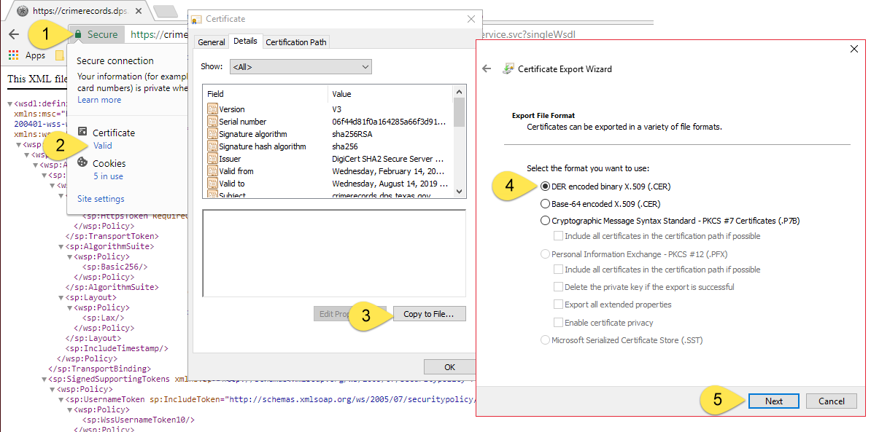

Worklists
A Worklist contains applicants of a specific description that are flagged as “Open”. Once an applicant has been returned to the calling application, it is flagged as “Closed” and will not be returned the next time the work list is requested. The applicant will also not be returned in any other Worklists since that applicant is now closed.

- New Applicant Submission – An applicant submission was processed and caused the applicant to be added to the Worklist.
NOTE: DPS does not recommend the SSN for identification of new applicants. When your applicant is being printed your applicant can be assigned a unique value or you can assign a unique value. Both these values can be found in the WsApplicant segment.
- Existing Applicants – Indicates if an Applicant Record is currently in the FACT Clearinghouse. Some Worklists require the agency to be subscribed to the applicant in order for the applicant to be added to the Worklist.
NOTE: For Subscription Events (like EVENT_CCH) DPS recommends you match on the SID (aka, DPS_NBR).
- Initial FBI Responses vs FBI Rap Back Responses – Worklist and Event Codes that reference “FBI” are in relation to the initial FBI Response that is receive when processing a new applicant submission. Worklist and Event Codes that reference “FRB” are in relation to FBI Responses receive when processing FBI Rap Back subscriptions.

Worklist Descriptions
The following table lists all Worklists and describes the types of applicants found. Worklists are based on what is most likely to follow as the next step in the workflow for processing an applicant.
EXAMPLE: In the table below an applicant that is found on the NEW_HIT_SOR Worklist may need to have their Public Sex Offender Record reviewed.
Work List Name | Description | Possible Agency Action
CONSOLIDATED* | [Obsolete] Applicants that have been assigned a new SID. | Update agency database to reflect new SID.
REJECT_FBI_MULTIPLE | Applicants whose fingerprints were rejected multiple times by FBI AFIS. | Initiate FBI Name Based background check.
REJECT_FBI | Applicants whose fingerprints were rejected by FBI AFIS. | Re-schedule applicant for FAST service.
REJECT_CCH | Applicants whose fingerprints were rejected by TX AFIS. NOTE: These records will have DPS_NBR=00000000 | Re-schedule applicant for FAST service.
NEW_NOHIT | Applicants that do not have a Texas, FBI or Sex Offender Criminal History. | Hire applicant
NEW_HIT_SOR | Applicants found in the Texas Public Sex Offender Registry. | - Pull Applicant Record including Texas Public Sex Offender Registry Record  - Initiate employment eligibility workflow to have criminal histories reviewed.  - Make determination for new hire.
NEW_HIT | Applicants that has a Texas, FBI or Sex Offender Criminal History. | - Pull Applicant Record  - Initiate employment eligibility workflow to have criminal histories reviewed.  - Make determination for new hire.
NEW_OTHER | New applicants that must be manually reviewed because their initial status could not be determined or has expired.
EVENT_SOR* | Applicants that have recently been added to the Public Texas Sex Offender Registry. | - Pull Applicant Record including Texas Public Sex Offender Registry Record  - Initiate workflow to review criminal histories and new registry record.  - Make determination of existing applicant.
EVENT_CCH* | Applicants that have a new qualifying event in the Texas Criminal History. | - Pull Applicant Record  - Initiate employment eligibility workflow to have criminal histories reviewed.  - Make determination on existing applicant.
EVENT_ALL | Applicants that have a new qualifying event in CCH, SOR or FBI. Requires FBI Rap Back Subscription.
NEW_SUBSCRIPTION * | An Applicant that was automatically subscribed to by your agency.
SUBSCRIPTION_VAL30  SUBSCRIPTION_VAL90 | An Applicant will appear on this worklist when the applicant is within 30/90 days being automatically unsubscribed. A subscription can be validated at any time. Requires FBI Rap Back Subscription. | Applicants on this worklist do not get closed. Either validate or unsubscribe the subscription.
SUBSCRIPTION_EXPIRED | An Applicant will appear on this worklist when the applicant has been automatically unsubscribed.
* Only available with applicants for which the agency has an active Texas Subscription.

Worklist Descriptions (for FRB)
The following worklists become available for agencies that participate in FBI Rapback
Work List Name | Description | Possible Agency Action
EVENT_FRB  EVENT_FBI | Applicants that have a new triggering event in the FBI Criminal History. Requires FBI Rap Back Subscription.
NEW_HIT_FRB  NEW_HIT_FBI | Subscriptions with an FBI Response received from a Rap Back Subscription (RBSR). Received response shows an arrest.
NEW_NOHIT_FRB  NEW_NOHIT_FBI | Subscriptions with an FBI Response received from a Rap Back Subscription (RBSR). Received response shows no arrest.

Worklist Contents
The following table shows the statuses for each of those data sources/responses and what Worklist they will be included in. There are four data sources/responses that determine what Worklists an applicant will be included in.
EXAMPLE: The table below shows an applicant with a FBI Response of REJECT will show on the REJECT_FBI Worklists.
Worklist Name | CCH Response | FBI Response | SOR Response | Event Code | Requirement
CONSOLIDATED |  |  |  | CONSOLIDATED
REJECT_FBI_MULTIPLE |  | REJECT |  |  | Must be at least +n in past x-days
REJECT_FBI |  | REJECT
REJECT_CCH | REJECT
NEW_NOHIT | NOHIT | NOHIT | NOHIT | INITIAL_NEW_NOHIT, INITIAL_RENEW_NOHIT | Must match all responses or have event code
NEW_HIT_SOR |  |  | HIT
NEW_HIT | HIT | HIT / (Unknown) | HIT | INITIAL_NEW_HIT, INITIAL_RENEW_HIT | Must match any
NEW_OTHER | NOHIT | (Unknown) | NOHIT
EVENT_SOR |  |  |  | SOR_EVENT
EVENT_CCH |  |  |  | CCH_EVENT  CCH_NEW_TRN  CCH_NEW_TRS
NEW_SUBSCRIPTION* |  |  |  | SUBSCRIPTION_NEW, SUBSCRIPTION_RENEW
SUBSCRIPTION_VAL90 |  |  |  |  | All active Subscriptions with a validation date within 90 days of being unsubscribed by the system.
SUBSCRIPTION_VAL30 |  |  |  |  | All active Subscriptions with a validation date within 30 days of being unsubscribed by the system.
SUBSCRIPTION_EXPIRED |  |  |  | EXPIRED | Subscriptions that have been recently unsubscribed by the system.

Worklist Contents (for FRB)
Worklist Name | CCH Response | FBI Response | SOR Response | Event Code | Requirement
NEW_NOHIT_FRB |  |  |  | FRB_NEW_NOHIT
NEW_HIT_FRB |  |  |  | FRB_NEW_HIT
EVENT_FRB |  |  |  | FRB_NEW_RBN
EVENT_ALL |  |  |  | CCH_NEW_TRN  CCH_NEW_TRS  SOR_NEW  FRB_NEW_RBN | Any open Subscription
NOTE: Worklist EVENT_ALL is not specifically related to FRB, but its availability is.

Applicants Moving Between Worklists
The worklist that an applicant appears on can change depending on the status of the applicant. The main scenarios in which this happens are:
- A new applicant receives FRB
- An applicant receives a qualifying event

An applicant receives a qualifying event
An applicant with an established subscription will appear on the EVENT_CCH worklist when there is a Qualify Event from Texas. This data is reported to the FBI. If the applicant also has an established FRB subscription, an RBN event will be generated and the applicant will move from the EVENT_CCH EVENT_FRB.
Because these processes are not instantaneous, an agency may first see the applicant on EVENT_CCH and again on EVENT_FRB, or an agency may only see the applicant on EVENT_FRB.
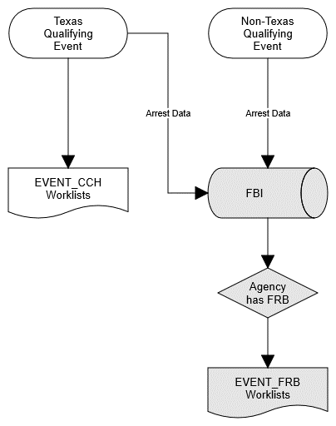

Applicants on Multiple Worklists
Applicants matching more than one Worklist that appear on all matching Worklists. The following table shows 4 Applicants and their status for each data source along with the Agency’s subscription status.

Example
Applicant JOHNSON has a Texas Criminal History (CCH Response = HIT) and an FBI Reject (FBI Response = REJECTED). Therefore, applicant JONSON appears on the Worklists REJECT_FBI and NEW_HIT. Closing applicant JOHNSON will remove the applicant from all Worklists.
 | ALBERTSON | JOHNSON | SMITH | GARCIA
Response Statuses
CCH Response | HIT | HIT | NO HIT | NEW EVENT
FBI Response | REJECTED | REJECTED | NO HIT
SOR Response
Agency is Subscribed |  |  |  | Yes
Worklists
REJECT_FBI | Included | Included
REJECT_FBI_MULTPLE | Included*
NEW_HIT | Included | Included
NEW_NOHIT |  |  | Included
EVENT_CCH |  |  |  | Included
* Assumes another recent FBI Reject exists for this SID.
Therefore, the order in which you process your worklist matters. Notice the difference between the two executions:
Execution 1:
- Request NEW_HIT
- See JOHNSON’s record is a HIT and PROCESS AS A HIT.
- Close JOHNSON’s record
- Request REJECT_FBI JOHNSON is no longer part of this worklist because the applicant is now closed.
Execution 2:
- Request REJECT_FBI
- See JOHNSON’s record is a REJECT and PROCESS AS A REJECT.
- Close JOHNSON’s record
- Request NEW_HIT JOHNSON is no longer part of this worklist because the applicant is now closed.

Web Service Examples
An example using SoapUI can be found in Appendix-A.

Example Agency/Service Interaction of New Applicants
The following show one possible workflow an Agency may have for processing new applicants. Start at the green dot; important steps are identified by the yellow icons that match the following steps:
- The agency starts by tracking an applicant in the Agency’s application.
- Rejected applicants would have to be scheduled for another fingerprint event.
- New Applicants without a hit would have their SID recorded in the Agency’s Application.
- New Applicants with a HIT would have to have their rap sheets manually reviewed by Agency Personnel.
- Agencies wishing to be notified of future qualifying events should subscribe to the applicant.

Example Agency/Service Interaction of New Qualifying Events
The following show one possible workflow an Agency may have for processing new qualifying events for subscribed applicants. Start at the green dot; important steps are identified by the yellow icons that match the following steps:
- A new qualifying is received. An example would be a new arrest.
- Review the updated Applicant Record to see new arrest data.
- If an applicant is no longer employed by the Agency, the applicant must be unsubscribed.

Example C# Code
The following code is from SampleCode.cs which can be found in the Clearinghouse 2 Service Client source code project. The code is for illustration purposes only and shouldn’t be run.
IMPORTANT: When the test web service is in "TESTMODE=TRUE" calling CloseApplicant() does not actually close the applicant’s record. This will cause GetWorkDetail() to continuously return the same applicants, effectively forming an infinite loop.
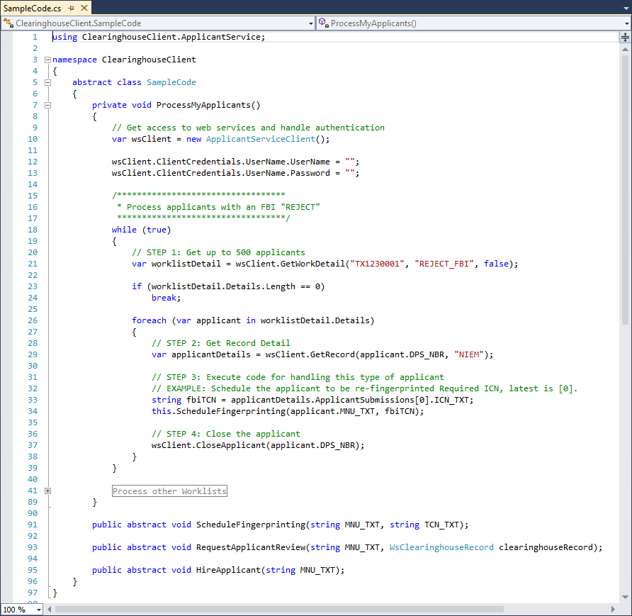

Example SOAP Message
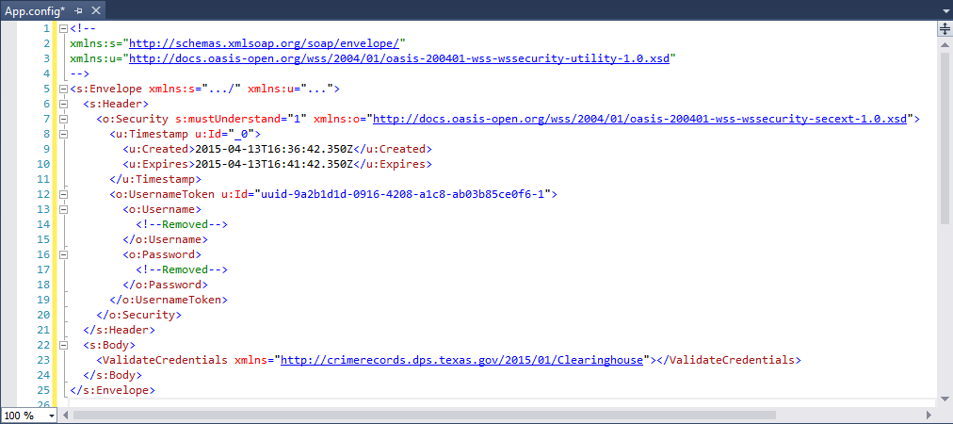

Subscription Validations
All Texas and FBI Rap Back Subscriptions must be regularly validated by the agency (See “Important Timeframes” for details). This ensures an agency is only subscribed to applicants that the agency is authorized to maintain an active subscription for.
An agency wishing to maintain a Texas Clearinghouse Subscription must validate the subscription before the subscription expires. If the subscription is not validated, it will be considered expired and will be canceled.
- WsSubscriptionRecord\VAL_DTE is the date a subscription was last validate.
- WsSubscriptionRecord\EXP_DTE is the date a subscription will expire.
- Validate() method will validate a subscription and update the VAL_DATE and extend the EXP_DTE.
Agencies may utilize the validation worklists to identify subscriptions that are due to expire. If an agency determines they are still legally authorized to maintain the subscription, the agency must validate the subscription prior to the subscription’s expiration date.
If a subscription is allowed to expire:
- The agency will no longer receive notifications of qualifying Texas events.
- The applicant will appear on the SUBSCRIPTION_EXPIRED worklists for 3-days as a means of notifying the agency that the subscription has been canceled.
- If the subscription includes an FBI Rap Back subscription, that subscription will also be canceled.
NOTE: These processes are not instantaneous and may require several days before completing.

FACT Clearinghouse Data Concepts

Changes to an Applicant Over Time
The following shows how an applicant’s record can change over time. The CCH Response works in a similar way, except that the CchResponseRecord is always up to date with the differences illustrated in the 4th step.
- On 1/2/2014, applicant is fingerprinted and is rejected by the FBI.
  - 1st WsApplicantRecord is created with FRT=REJECT
  - No FBI Response is available
- On 2/3/2015, applicant is re-fingerprinted and no criminal history was found at the FBI
  - Notice: 1st WsApplicantRecord still shows FRT=REJECT
  - 2nd WsApplicantRecord is created with FRT=NOHIT
  - A FBI Response is available, reflects 2/3/2015 date
- On 4/5/2015, applicant is fingerprinted for another agency (not shown).
  - Notice: 1st WsApplicantRecord still shows FRT=REJECT
  - Notice: 2nd WsApplicantRecord still shows FRT=NOHIT
  - No new WsApplicantRecord is available
  - A FBI Response is available, reflects 3/4/2015 date
- On 5/6/2015, agency views the applicant again.
  - Notice: FBI is still dated 3/4/2015
  - CCH Response shows CRT=HIT and reflects the date the record was accessed. Even if there was no change to the CCH Response, this CCH Response would still reflect the date the record was accessed.

Closing an Applicant
An applicant can be open because of:
- One or more new Applicant Submission records (Each defined by an ApplicantId)
- Changes to an Applicant Subscription (Defined by the SID, aka DPS_NBR).
When you close an applicant using either of the close applicant methods, both sets of records will be closed. In Example  there are two open applicant submission records and an open subscription. All these records are closed when closing any of the following values:
- SID=07777777
- ApplicantId=1000
- ApplicantId=1001
All data is associated with by SID. In example  the Applicant Submission is Texas Reject so there is no SID (DPS_NBR=00000000) and therefore no associated Applicant Subscription. This means you must close the applicant using:
- ApplicantId=1003
If there is a change to an Applicant Subscription, there may or may not be an associated Applicant Submission. In example  there is no associated Applicant Submission and therefore no ApplicantId. Some reasons there may not be an Applicant Submission:
- The Subscription was manually created (instead of being automatically created from an Applicant Submission)
- The only Applicant Submissions associated with the SID is no longer available.
In this example you must close the applicant using:
- SID=07777777
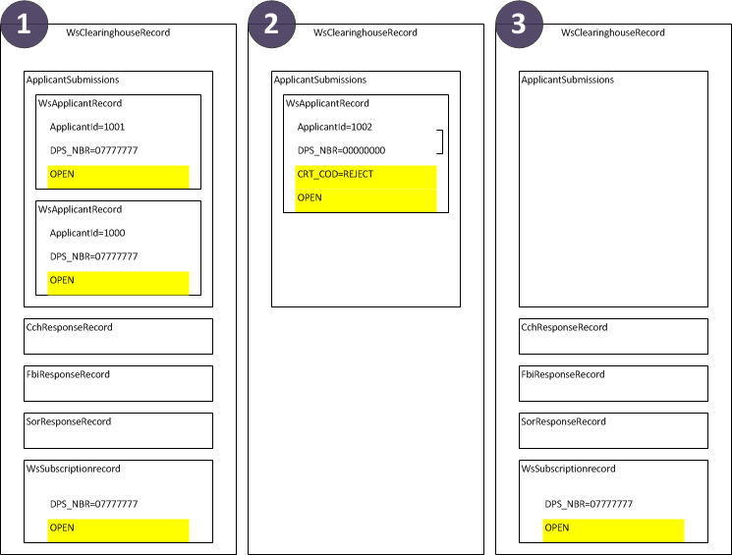

Auto-Closing Applicants
Applicant Submissions and Subscriptions are automatically closed after a period of time (See “Important Timeframes”). This only applies to applicants on the following worklists:
- NEW_HIT
- NEW_HIT_SOR
- NEW_NOHIT
- NEW_OTHER
- NEW_SUBSCRIPTION
- NEW_HIT_FRB
- NEW_NOHIT_FRB
- REJECT_CCH
- REJECT_FBI
- REJECT_FBI_MULTIPLE

Texas Criminal History Concepts

Consolidations
A consolidation of records within the Computerized Criminal History Database (CCH) is when the data from one SID is moved to another SID. Identifying information (e.g. Names & Birthdates) and arrest information are moved from the KILL SID onto the KEEP SID. A stub record that represents the KILL SID continues to exist with a reference to the KEEP SID.
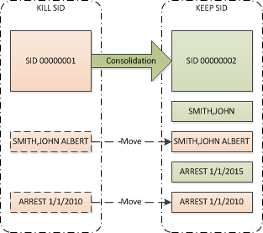

Searching for Consolidated SIDs
When searching for a record by KILL SID, the stuff record is used to identify the KEEP SID and the KEEP SID is used for returning the results.
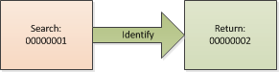

Impact to Subscriptions
If an agency is subscribed to a SID that is consolidated, the subscription to that KILL SID is disabled and a new subscription with the KEEP SID is created. If a qualifying event occurs, it is added to the KEEP SID subscription and the agency is notified of an event for the new SID.
If an agency receives a subscription event and the SID is unknown, the notification may be for a subscription that was created because of a consolidation. The agency can identify an Applicant’s original (KILL) SID in the following ways:
- Instance of WsIdentifiers (Source=CCH, Key=CONSOLIDATED_SID) in WsClearinghouseRecord
- In Texas Criminal History Response (if using the XML format) by the existence of the element INDV/ConsolidatedFrom/RelatedRecord
Agencies that use the MNU/OCA for matching FACT Clearinghouse data to their systems do no need to do anything specific with consolidated records since the MNU is part of the identifying information that is moved from the KILL SID to the KEEP SID.

FBI Rap Back (FRB) Subscriptions
An FRB Subscription will allow your agency to receive notification of qualifying events that occur outside of Texas. The primary benefits of having a Rap back subscription are:
- Ensure the FBI Response portion of the Record Detail is always up to date.
- Receive notification of changes to the FBI Response portion of the Record Detail.
From a technical point of view, an agency does not require any changes to use Rap back. Worklists exist for processing FBI Rap Back Subscription events and the RBTED data element further identifies why a new FBI response was added.
Notice – Once enabled for Rap Back, your agency will start receiving additional FRB Worklists. Please ensure your application can support these.

Eligibility
To enable FRB Subscriptions, the agency and individual ORI’s associated with the agency must be configured by DPS.
- Agency requirements:
  - Be configured in Clearinghouse for FRB
  - Have one or more ORI’s configured for FRB
  - Have correct waiver/legal language on file
- Applicant requirements:
  - Have prints retained by the FBI. Applicants that have a valid FBI Response obtained for applicant purposes since 2015-06-15 identify these applicants. Said response must have a EVI value and must be tracked within the FACT Clearinghouse.
  - Have an Active FACT Clearinghouse Subscription.

A new applicant receives FRB
In the following scenario, a new applicant is printed for FACT Clearinghouse. The applicant is likely to land on the NEW_HIT or NEW_NOHIT worklist. When the applicant is eligible for FRB, the shaded logic applies. After an FRB Subscription (RBSCVL) is established the applicant is removed from NEW_HIT/NEW_NOHIT worklists onto the NEW_HIT_FRB/NEW_NOHIT_FRB.
Depending on when an agency pulls the applicant, the applicant may be on any of the following worklists:
- NEW_HIT/NEW_NOHIT
- NEW_HIT_FRB/NEW_NOHIT_FRB
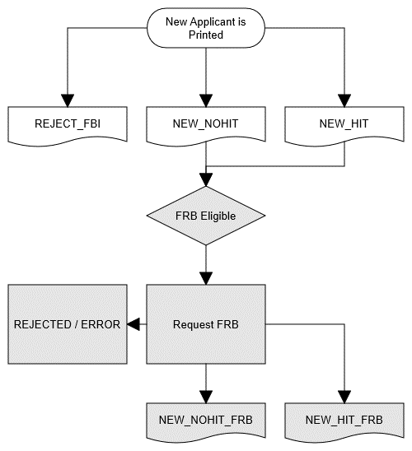

Rap Back Activity Notification (RBN)

FRB Data Elements
- RBTED - RAP BACK TRIGGERING EVENT DETAILS
- FBI Subscription Status
  - SUBSCRIBED -- An active FRB Subscription exists
  - ELIGIBLE -- Agency and Applicant are eligible for FRB, but FACT has not yet attempted to establish an FRB subscription.
  - PENDING -- FACT has attempted to establish an FRB subscription, but one has not yet been established (Internal status is NEW, ERROR or CANCELED)
  - NOT ELIGIBLE -- Agency is eligible, but no eligible Application Submission exists.
- FBI Subscription Status Date

RBTED Data Elements
The RBTED data element (found on the FBI Response) identifies why an FBI response was added. This only applies to FBI Responses that were received from the FRB process. Example value:
NCIC WANTED / PERSON ENTRY FROM ORI - NY0303000: NIC/12345, DATE OF WARRANT 20140511{GS}
Section “RBTED 2.2069 Rap Back Triggering Event Details” of the Master EBTS documentation further define this section. Configuration by DPS specifies the specific events that generated are and may change from agency to agency.

Rejected RBSCVL Transactions
In case of reject or error, TX DPS will retry establishing the transaction. It should be noted that an FRB Subscription is not guaranteed. In some cases the only way to establish a FRB Subscription is to re-print the applicant, which may incur additional fees.

Prevalidation
Before the displaying an ERS (FBI Response) that was received from an RBN (FBI Rap Back Notification), the FBI requires that the subscriber (Agency) verifies they are still in an authorizing relationship with that person (applicant). This is a person that is still licensed, is still employed, is still volunteering, etc for that agency. An agency verifies their relationship with the applicant by validating their subscription.
The requirements of prevalidation are met when the subscription has been validated after the RBN event was generated. Prevalidations occur when processing virtually all applicants found on the EVENT_FRB worklist. Therefore, agencies should have a process in place to verify their relationship with an applicant before processing the EVENT_FRB worklist.

To report that an Agency is still in an authorizing relationship with that person, the agency may do either of the following:
- Call the Validate() method before calling GetRecord().
- Call the GetRecord() method, passing validateAction=prevalidate.
If the requirements of prevalidation are not met, an exception is thrown when GetRecord() is called:
PREVALIDATION: SID=######## requires validation

Consolidations
When a SID is consolidated, a new FBI Rap Back Subscription is established and the old one is canceled. A new ERS is returned and may cause the applicant to appear on a worklist.

Data Formats

<WsClearinghouseRecord> Example
<WsClearinghouseRecord xmlns:xsd="..." xmlns:xsi="...">
<ApplicantSubmissions>
<WsApplicantRecord>
<ApplicantId />
<CRS_COD>DONE</CRS_COD>
<CRT_COD>HIT</CRT_COD>
<DOB_DTE />
<DPS_NBR />
<FBI_NBR />
<FBI_TXT />
<FRS_COD>DONE</FRS_COD>
<FRT_COD>HIT</FRT_COD>
<ICN_TXT />
<NAM_TXT />
<OCA_TXT />
<OLN_NBR />
<ORI_TXT />
<SCO_TXT />
<SEX_COD>M</SEX_COD>
<SOC_TXT />
<TCN_TXT />
<TRA_DTE />
</WsApplicantRecord>
</ApplicantSubmissions>
<CchResponseRecord>
<CRT_COD>NOHIT</CRT_COD>
<RSP_DTE />
<ResponseText>
<!-- ... -->
</ResponseText>
</CchResponseRecord>
<DPS_NBR />
<FbiResponseRecord>
<FRT_COD>HIT</FRT_COD>
<ORI_TXT />
<RSP_DTE />
<RBTED />
<ResponseText>
<!-- ... -->
</ResponseText>
</FbiResponseRecord>
<Identifiers>
<WsIdentifier>
<Key>CONSOLIDATED_SID</Key>
<Source>CCH</Source>
<Value>09703906</Value>
</WsIdentifier>
</Identifiers>
<NAM_TXT />
<SorResponseRecord>
<RSP_DTE>2015-07-08T10:36:20.9510296-05:00</RSP_DTE>
<ResponseUrl>https://.../Individual.aspx?DPS_NBR=50512401</ResponseUrl>
<SRT_COD>HIT</SRT_COD>
</SorResponseRecord>
<SubscriptionRecord>
<DOB_DTE>0001-01-01T00:00:00</DOB_DTE>
<DPS_NBR />
<EVT_COD />
<EVT_DTE>0001-01-01T00:00:00</EVT_DTE>
<HasSubscription>false</HasSubscription> [Obsolete]
<IsOpen>false</IsOpen>
<NAM_TXT />
<SEX_COD />
<TXSubscriptionStatus>ACTIVE</TXSubscriptionStatus>
<FRBSubscriptionStatus>ACTIVE</FRBSubscriptionStatus>
</SubscriptionRecord>
</WsClearinghouseRecord>

<WsCchResponseRecord>

GetRecord() “Format” Parameter
When calling the GetRecord() method there are two options for the format in which the Texas Criminal History response is returned (WsCchResponseRecord). Both options return the same information, but in different formats:
- XML – This XML is based on the data structure of the Texas Criminal History Database.
- NIEM – This is a NIEM compliant XML data structure.

Use of <xsd:any>
An XSD document is an XML document that describes/validates another XML document. A WSDL document is specific type of XSD that is used for describing/validating a web service. The <any> element of an XSD document allows the document being described/validated to include XML that is not described/validated.
The element <ResponseText> (within <WsCchResponseRecord>) is defined as <any> for the following reasons:
- The response can be of different XML formats.
- The WSDL is simpler.
- Additional formats can be added supported without publishing a modified WSDL.
Please note that this section also applies to the WsFbiResponseRecord type.
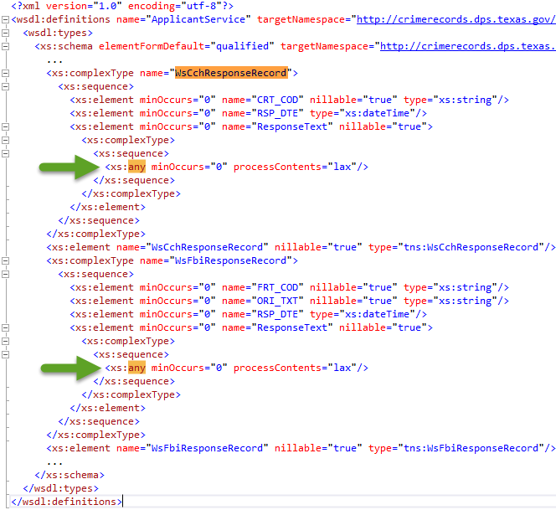

Sample format=XML
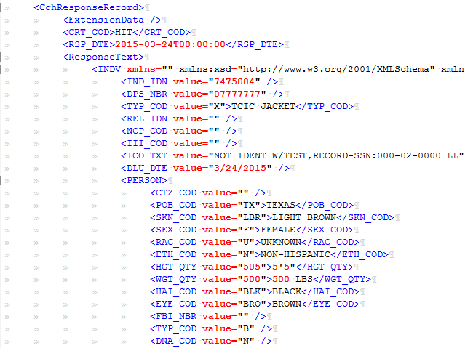

Sample format=NIEM
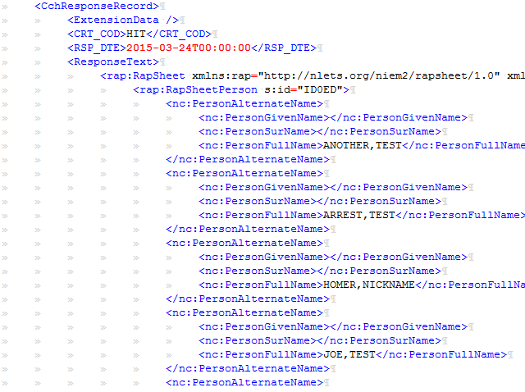

Service Methods
Operation Name | GetWorkSummary()
Description | Returns a summary of all open applicants for the Agency.
Return Value | WsWorklistSummaryItem[]
Parameters | Type | Name | Description

Operation Name | GetWorkDetail()
Description | Returns the first 500 applicants in the specified worklist. To get additional applicants from a worklist, first close some of the returned applicants.
Return Value | WsWorklistContainer[]
Parameters | Type | Name | Description
 | String | Ori | Originating Agency Identifier
 | String | worklist | Worklist Type
 | Bool | closeOnReceive | Close applicants once returned. Not yet supported.

Operation Name | CloseApplicant()
Description | If an applicant submission is rejected by Texas AFIS this method will not work because you will not have a SID. You will have to close using the ApplicantId.
Return Value
Parameters | Type | Name | Description
 | String | sid | Cannot be 00000000. This is also known as DPS_NBR.

Operation Name | CloseApplicantByApplicantId()
Description | Used for closing Applicant Submissions rejected by Texas AFIS.
Return Value
Parameters | Type | Name | Description
 | Int | applicantId

Operation Name | Subscribe()
Description
Return Value
Parameters | Type | Name | Description
 | String | sid | This is also known as DPS_NBR.
 | String | ori | Originating Agency Identifier

Operation Name | SubscribeWithKey()
Description
Return Value
Parameters | Type | Name | Description
 | String | sid | This is also known as DPS_NBR.
 | String | ori | Originating Agency Identifier
 | String | key | Allow custom identification of the applicant.

Operation Name | Unsubscribe()
Description
Return Value
Parameters | Type | Name | Description
 | String | sid | This is also known as DPS_NBR.

Operation Name | Validate()
Description | Validate a subscription. [NEW for v2]
Return Value
Parameters | Type | Name | Description
 | String | sid | This is also known as DPS_NBR.

Operation Name | GetRecord()
Description | Returns identification information related to the SID, including Texas, FBI or Sex Offender record details. Some agencies will be charged a fee for calling this method under certain circumstances.  Will throw an exception if prevalidation is required. See the section “prevalidate” for additional details.
Return Value | WsClearinghouseRecord
Parameters | Type | Name | Description
 | String | sid | This is also known as DPS_NBR.
 | String | format | Xml|Niem. Format applied to Criminal History Response Text.
 | Bool | closeOnReturn | Setting to True will automatically call CloseApplicant()
 | String | validateAction | - None – No Validation  - Prevalidate – Validate if required for prevalidation  - Validate – always validate

Operation Name | GetRecordSummary()
Description | Returns identification information related to the SID, without Texas, FBI or Sex Offender record details. There is no fee associated with making this service call. [NEW for v2]
Return Value | WsClearinghouseRecord
Parameters | Type | Name | Description
 | String | sid | This is also known as DPS_NBR.

Operation Name | GetPhoto()
Description
Return Value | Byte[]
Parameters | Type | Name | Description
 | Int | imgIdn

Operation Name | ValidateCredentials()
Description
Return Value | Bool
Parameters | Type | Name | Description

Operation Name | ServerInfo()
Description
Return Value | String[]

Data Objects

WsWorklistSummaryItem
Description | Returns the number of applicants that are within a specific worklist.
Usage | Allow application to know which worklists contain applicants or give users an estimated workload.

Property Name | Property Type | Remarks
Worklist | String
ORI_TXT | String | Originating Agency Identifier
ATR_TXT | String | Agency Name
ApplicantCount | Int

WsWorklistContainer
Description
Usage

Property Name | Property Type | Remarks
ORI_TXT | String | Originating Agency Identifier
ATR_TXT | String | Agency Name
CloseBatchTrace | String
Details | WsWorklistRecord[]

WsWorklistRecord
Description | Describes an applicant that matches the worklist it was retrieved from. If ApplicantId exists, then there is a new FAST Applicant Submission to review, otherwise there is a subscription event to review. ResponseStatus values are at the time the record was processed, the older the record the more likely the ResponseStatus is no longer valid.
Usage | Use DPS_NBR to get additional details on the applicant. ApplicantId can be used for closing Texas AFIS Rejects.

Property Name | Property Type | Remarks
ApplicantId | Int | Uniquely Identifies an Applicant Submission.
DPS_NBR | String | Aka “SID”. Has a value of 00000000 for Texas AFIS Rejects. Otherwise always populated.
ORI_TXT | String | Originating Agency Identifier
NAM_TXT | String | Applicant Name
EVT_DTE | DateTime | Fingerprint Event of Subscription Event date
CchResponseStatus | String | REJECT|HIT|NOHIT
FbiResponseStatus | String | REJECT|HIT|NOHIT
SubscriptionStatus | String
SorResponseStatus | String | HIT|NOHIT
EVT_FLG | Bool | True: applicant record is open.
MNU_TXT | String | Unique agency identifier submitted through FAST process.

WsApplicantRecord
Description | Represents an instance of an Applicant being fingerprinted via FAST. HIT/NOHIT flags are set at the time the record was processed, not at the time the record was accessed.
Usage | Client application should act upon this depending on the CCH & FBI Responses. A CCH or FBI Reject may result in the Client application requesting the applicant to reschedule a fingerprinting. A CCH or FBI “HIT” may trigger the client application to pull the Criminal History for review.

Property Name | Property Type | Remarks
ApplicantId | Int | Uniquely Identifies an Applicant Submission.
DPS_NBR | String | Aka “SID”. Has a value of 00000000 for Texas AFIS Rejects. Otherwise always populated.
TRA_DTE | DateTime | Date Submission Record was submitted.
CRS_COD | String | CCH Status (HOLD|DONE)
CRT_COD | String | CCH Response (REJECT|HIT|NOHIT)
DOB_DTE | Date | Applicant Date of Birth
FBI_NBR | String | FBI Number
FBI_TXT | String | FBI Reject Text
FRS_COD | String | FBI Response (NONE|WAIT|DONE) NOTE: Applicants returned on a Worklist
FRT_COD | String | FBI Type (REJECT|HIT|NOHIT)
ICN_TXT | String | ICN (aka: FBI’s TCN)
NAM_TXT | String | Applicant Name
OLN_NBR | String | OLS_COD + OLN_NBR
ORI_TXT | String | Originating Agency Identifier
SCO_TXT | String | SCO
SEX_COD | String | Sex
SOC_TXT | String | Social Security Number
TCN_TXT | String | TCN / Transaction Control Number
OCA_TXT | String | Unique agency identifier submitted through FAST process. Also known as MNU or Agency Case Number.

WsClearinghouseRecord
Description | Combination of various Criminal History records.
Usage | Display to user to allow determination to be made.

Property Name | Property Type | Remarks
DPS_NBR | String | aka “SID”
NAM_TXT | String | Name
ApplicantSubmissions | WsApplicantRecord[] | (Optional)
SubscriptionRecord | WsSubscriptionRecord | (Optional)
FbiResponseRecord | WsFbiResponseRecord | (Optional) Always a space-formatted data
CchResponseRecord | WsCchResponseRecord | (Optional) Includes Criminal and/or Applicant Record
SorResponseRecord | WsSorResponseRecord | (Optional)
Identifiers | WsIdentifiers | Format: “{Type}:{Value}”  SID:01234567  SID:01234568  MNU:EMP1234

WsCchResponseRecord
Description | Texas Criminal History Record. Non-Criminals will only have detailed identification information. Criminals will have arrest and charge information.
Usage

Property Name | Property Type | Remarks
RSP_DTE | DateTime | Date of Response. This is CCH’s DLU – NOT Today’s Date.
CRT_COD | String | Response Type. HIT | NOHIT
ResponseText | XmlElement | Formatted (xml/niem/html/etc.) version of serialized INDV)

WsFbiResponseRecord
Description | FBI Criminal History Record. Non-Criminals will only have detailed identification information. May include Texas arrest information that is also available in the Texas Criminal History Record.
Usage

Property Name | Property Type | Remarks
RSP_DTE | DateTime | Date of Response
FRT_COD | string | Response Type (HIT | NOHIT)
ResponseText | XmlElement | Formatted xml with root node <Lines> and child nodes <Line row=”1”>… </Line>
ORI_TXT | String | Originating Agency Identifier
RBTED | String | FBI Rap Back Triggering Event Data. Populated from a FRB Subscription Event.
PrevalidationRequired | Bool | Indicates prevalidation required. If True, then ResponseText will be empty.

WsSorResponseRecord
Description | Public Texas Sex Offender Registry Indicator.
Usage | If HIT, then allow the user to navigate to the URL to view the Public SOR Record.

Property Name | Property Type | Remarks
RSP_DTE | DateTime | Date of Response
SRT_COD | String | HIT|NOHIT
ResponseUrl | String | URL to record on Texas Public Sex Offender Registry.

WsSubscriptionRecord
Description | Details of Agency’s Subscription to an Applicant.
Usage | Use the EVT_COD to determine what has triggered the subscription to be opened. If the agency does not have a subscription, but this element exists, then default values are populated.

Property Name | Property Type | Remarks
DPS_NBR | String | aka “SID”
DOB_DTE | DateTime | Date of Birth
EVT_COD | String | Event Code
EVT_DTE | DateTime | Event Date
EVT_TXT | String | Event Text
NAM_TXT | String | Name
SEX_COD | String | Sex
IsOpen | Bool | This subscription event has not been closed by the user.
VAL_DTE | Date | Date of last subscription validation
HasSubscription [Obsolete] | Bool | [Removed in v2]
TXSubscriptionStatus | String | Texas Subscription Status  {TBD} ACTIVE | ELIGIBLE
FRBSubscriptionStatus | String | FBI Rap Back Subscription Status  {TBD} See FRB Section Above
EXP_DTE | Date | Subscription Expiration Date

WsIdentifiers
Description | Collection of various values that identify this specific applicant.
Usage | Currently can only be used to identify additional SIDs that the applicant is known by. Future use may include FBI Subscription Identifiers, Agency MNU/OCA values.

Property Name | Property Type | Remarks
Source | String
Key | String
Value | String

Applicant Record Messages
Code | OPEN
Title | Applicant Record Is Open
Description | This applicant is new or your Agency’s Subscription has indicated a status change. Close the Applicant once the record has been reviewed.

Code | SUBSCRIBED
Title | Your Agency Is Subscribed
Description | Your agency is subscribed to this applicant and will receive notification for certain events.

Code | CCH_OUTDATED
Title | Identifiers Not Updated
Description | Although all Arrest, charge and FBI data is up to date, CCH has not been updated since the last applicant submission from your agency. This may result in your agency's identifiers missing from the applicant’s record.
Logic | DLU in CCH is older than the Transaction Date of the last Applicant Submission

Code | FBI_REJECT
Title | FBI Response Rejected
Description | The last Applicant Submission for this applicant was rejected by the FBI AFIS. If an FBI Response is present it is from a previous Applicant Submission.

Code | FBI_OUTDATED
Title | FBI Response May Be Out of Date
Description | An Applicant’s FBI Record is only updated when an Applicant Submission is processed. The greater the time between accessing an FBI Record and the last Applicant Submission offers a greater chance of new FBI Arrest data not being reflected in the FACT Clearinghouse.
Logic | Display if latest FBI Response is past threshold.

Code | FBI_PENDING
Title | FBI Response not Received
Description | An Applicant’s FBI Record has not yet been updated for the last applicant submission. To view the updated FBI Record return to this Applicant Record at a later time.

Code | FEE_WARN
Title | Fee-Based Record Access
Description | Your agency does not have a recent Applicant Submission for this applicant, therefore requesting access to the Texas Arrest & FBI Arrest Records (even if not present) will incur a cost for your Agency.
Logic | Only displayed if Organization is PrePay or Billable

Important Timeframes
Description | Start Time | Range from Start
View an Applicant Record without a charge | Last Applicant Submission | 31-days
View an Applicant Record without a charge | FBI Subscription Established | 31-days
Access to Applicant Submission | Submission Event Date | 3-Months
Applicant Submission HIT/NOHIT Indicators | Submission Event Date | 1-Month
Warning of outdated FBI Response | Submission Date of Last valid FBI Response | 6-Months
Disabling of Invalid Subscriptions | From Removal of qualifying applicant flag | 24-Hours
Reprint after the First FBI print Rejection | Date of Rejection | One year
Request a Name-Based Search after the second FBI print Rejection | Date of 2nd Rejection | 90 days
Reach-back date for auto-subscribing to applicants | Submission Event Date | 6-months
Auto-Closing of Applicant | Subscription Event Date or Applicant Submission Date | 3-MOnths
Validation of Texas Subscriptions | Last Subscription Validation Date | {TBD}-Years

Frequently Asked Questions

Q: When am I charged for viewing a record?
You are charged when calling GetRecord() unless:
- RULE1: The most recent Applicant Submission’s transaction is within the past 31-days.
- RULE2: An FRB Subscription was established in the past 31-days.
- RULE3: Your agency is already being charged for viewing the record in the same calendar month. This means you will only be charged once a month for view a record.
NOTE: You are LIKELY to be charged when pulling records from the new event worklists (like EVENT_CCH & EVENT_FRB) because these worklists are not populated based on new applicant submissions and most often occur well after the latest applicant submission.
NOTE: You are UNLIKELY to be charged when pulling records from the “new applicant” worklists (like NEW_HIT & NEW_NOHIT) because these are populated when a new applicant submission is received.
<WsClearinghouseRecord xmlns:xsd="..." xmlns:xsi="...">
<ApplicantSubmissions>
<WsApplicantRecord>
<TRA_DTE /> ← RULE1: If this is older than 31-days, you’ll be charged $1 for calling GetRecord().

<SubscriptionRecord>
<DOB_DTE />
<DPS_NBR />
<EVT_COD /> ← RULE2: If this indicated FRB was established, like FRB_NEW_NOHIT…
<EVT_DTE /> ← RULE2: …and this is < 31-days old
<HasSubscription>false</HasSubscription>
<IsOpen>false</IsOpen>
<NAM_TXT />
<SEX_COD />
</SubscriptionRecord>

Q: Why doesn’t my recently fingerprinted applicant show an updated FBI Response Date?
This is likely because you had a FRB subscription established before your applicant was last printed. You are seeing the latest FRB Response, not the latest FBI Response from the fingerprint event.
Explanation:
There are two tables of FBI Responses:
- Table 1 is for the FBI Responses from the fingerprint events.
- Table 2 is for the FBI Responses from the FBI Rap Back program.
If an applicant does not have FRB, GetRecord() returns the latest FBI Response from Table 1.
If an applicant does have FRB, GetRecord() returns latest FBI Response from Table 2.
What is happening:
- In 2018 the applicant is printed, causing a response to be added to Table 1
- In 2018 FRB is established, causing a response to be added to Table 2
- In 2020 the applicant is printed, causing a response to be added to Table 1
There was never any change to the FBI record and therefore there was never an update to Table 2. When calling GetRecord() [for an applicant with FRB], the response from Table 2 was returned.
If, in 2019, there was a change to the FBI record it would have been pushed to you via the EVENT_FRB worklist. You would have received the updated FBI Response without having to get printed.
NOTE: Technically (vs by Policy) a new fingerprint submission is not required when FRB has been established (that is the purpose of FRB.)
NOTE: In <ApplicantSubmission>, of the response return from GetRecord(),both the 2018 and 2020 fingerprint events will represented.

Glossary
Applicant – A person that is submitting, or has previously submitted, fingerprints for the purpose of obtaining a criminal history check for an authorized purpose. Applicant fingerprint based results are stored in the CCH and, if present, are associated with the Texas arrest data in the CCH.
Applicant Purpose – An authorized reason an agency is allowed to request a criminal history check on an individual (i.e. 411 Legislative Code, NCPA).
Applicant Purpose Group – Applicants printed for the same applicant purpose. Agencies in the same Applicant Purpose Group have access to and can share the same criminal history records subscription through the FACT Clearinghouse.
Applicant Record –An applicant record based on a consolidated response of the most recently reported Identification and arrest information from the CCH, Applicant Submissions and Subscription from the FACT Clearinghouse and the last reported FBI Response.
Applicant Submission – An applicant submission is a specific instance of fingerprints being submitted for the purpose of obtaining a computerized criminal history.
Applicant Submission, Completed Status – An applicant submission record where both CCH and FBI systems have accepted the quality of the fingerprints and the final CCH and initial FBI Response has been received.
Applicant Submission, Pending Status – An applicant submission record where the record has not yet been updated in the criminal history database or the FBI Response has not yet been received.
Applicant Submission, Rejected Status – An applicant fingerprint submission with an accepted CCH Response but a rejected FBI Response. Records with a rejected FBI response will have a CCH subscription created, if required.
ERS (Electronic Rap Sheet) – Includes the FBI Criminal History Record displayed in the FACT Clearinghouse.
FBI AFIS Response – The FBI responds to fingerprint requests with one of the following:
- “Identified” followed by arrest information presented in a text-formatted message. This arrest information may include Texas and Non-Texas arrest information.
- “No Prior Arrest” presented in a text-formatted message
- Various “Rejected” codes with corresponding explanations of the reason for the rejection
FBI Criminal History – A FBI response, also known as Identity History Response, to a fingerprint matching response for an applicant submission from the FBI indicating if the applicant is on file and if the applicant has associated FBI Arrest Data or was previously fingerprinted for identification purposes.
FBI Qualifying Event – The following events reported to the FBI will trigger an updated FBI criminal history to be sent to a subscribed agency; arrest, record updates, death notices, and SOR Additions, Modifications, and Deletions.
FBI Rap Back Subscription – A subscription created with the FBI per SID with DPS. The access to the subscription will be granted to an organization by DPS that meet the federal statute authority to view the national criminal history record information. The results to the FBI Subscriptions and any events will be provided in the Clearinghouse.
An agency subscribed to a SID that has an active FBI Rap Back (FRB) Subscription will be notified when a qualifying event (disposition update, new arrest information, etc.) is reported to the FBI pertaining to the subscribed SID.
FBI Subscription Event - A FBI Subscription Event is generated when there is a recent event reported to the FBI from Texas and/or other states.
Identification Record – Identification information (Name, Sex, Race, etc) that is shared by Applicant Records and Criminal Records.
Notification – An automated message received in an agency’s Secure Site Message Center indicating an initial CCH/FBI or subsequent FRB subscription has been created for the agency, or new CCH/FBI arresting information has been providing to the agency on an active subscription.
Notification Recipient – An active Authorized User on the Secure Site who has elected to receive either subscription (Sub), event (Data), or both, notifications as indicated on the Notification Settings page of the Clearinghouse.
Open Applicant – The state of an applicant when a new Qualifying Event or Texas Subscription Event has occurred, and the applicant record has yet to be reviewed by the Agency.
Subscription Validation– Validation for an FRB Subscription that is still required by the subscribed agency to prevent it from expiring.
Texas Criminal History – A record of the latest information that has been reported to the Computerized Criminal History database (CCH) for fingerprints retained by the Department. The data presented in a Criminal Record contains identification and arrest information. It is available in both a custom XML and NIEM format. A Criminal Record may also be a CCH Applicant Record.
Texas MBIS Response – A fingerprint matching response for an applicant submission from CCH indicating if the applicant is on file and if the applicant has associated CCH Arrest Data or was previously fingerprinted for identification purposes.
Texas Qualifying Event – The following events reported to DPS will trigger an updated Texas criminal history to be sent to a subscribed agency; new arrest, new charges, and additions to SOR.
Texas Subscription – A subscription is the association of a SID with an Organization that results in the agency being notified of changes to the Clearinghouse record by the way of a Subscription Event notification.
Texas Subscription Event – A Subscription Event is generated when there is a change to the previously reported status of the CCH portion of a subscribed record.
Worklists – lists that are created for agencies to view initial criminal history responses, new Texas and FBI subscriptions, and new qualifying events.

Appendix A – Using SoapUI
Instructions for calling the ValidateCredentials() method using SoapUI.
- Setup the WSDL
- Configure the Endpoint
- Setup WS-Security
- Instruct the Method to use WS-Security
- Execute the method

Setup the WSDL
- Create an empty project
  - Open “File” Menu
  - Select “Create Empty Project”
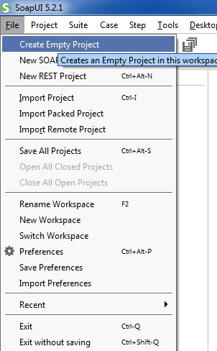
- Add a WSDL to the project
  - Right-Click on the Project
  - Click “Add WSDL”
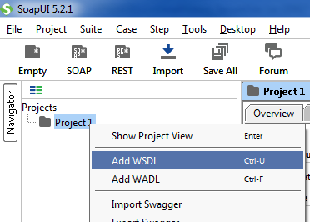
  - Enter the URL for the WSDL & click OK.
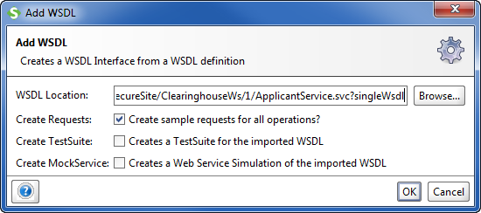
You should now see the methods:
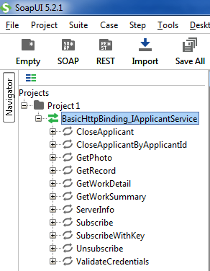

Configure the Endpoints
- Click on the WSDL
- Navigate to the “Service Endpoints” tab
- Update the endpoint to the original WSDL’s URL
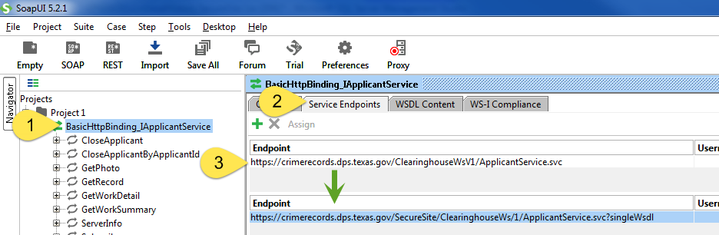

Setup WS-Security
- Double-Click on the Project folder
- Navigate to the tab “WS-Security Configurations”
- Click on “+”
- Enter any configuration name
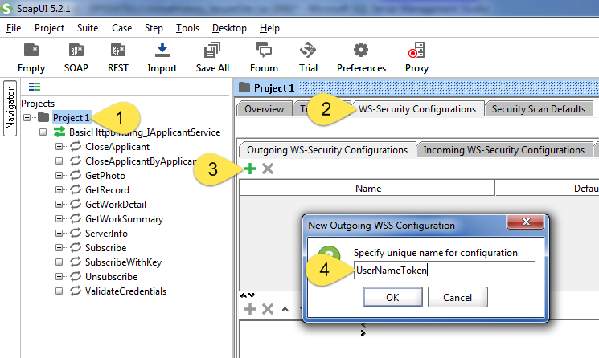
- Enter your user name & passwords
- Select “Must Understand”
- Click “+”
- Choose “Username”
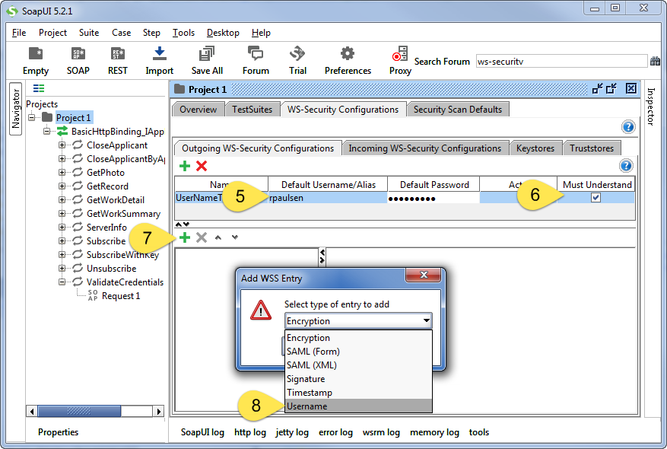
- Choose password type of “PasswordText”
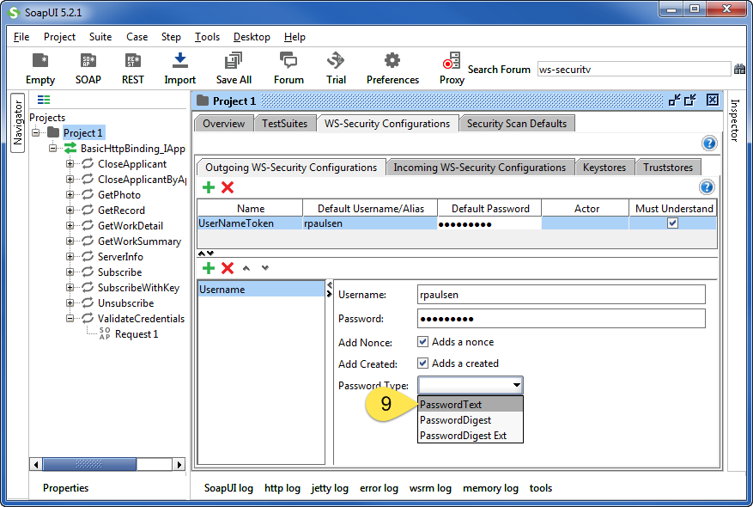

Instruct the Method to use WS-Security
- Click on the request
- Navigate to the “Auth” panel
- Select “Add new Authorization”
- Select “Basic” and click ok.
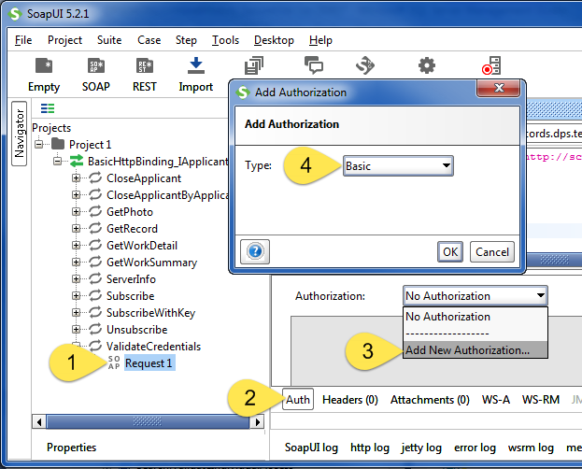
- Select the item you created previously.
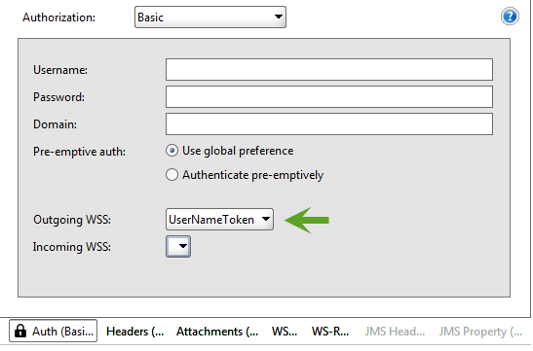

Execute the Method
- Select the request to run
- Click “Play”
- Result should display. If not, confirm you are using the correct password.
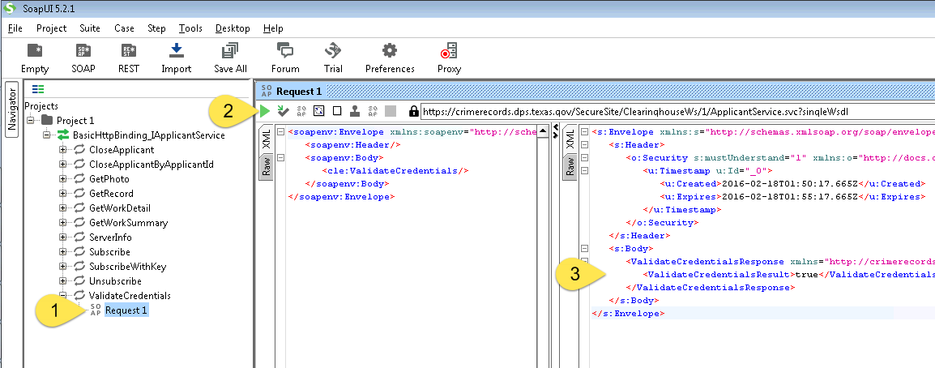

Appendix B – Using the WS Client

STEP 0 – Confirm User Name
- Confirm you can connect to the WS by entering your User Name and Password, then clicking Login
- You should see a response that does not indicate an error.
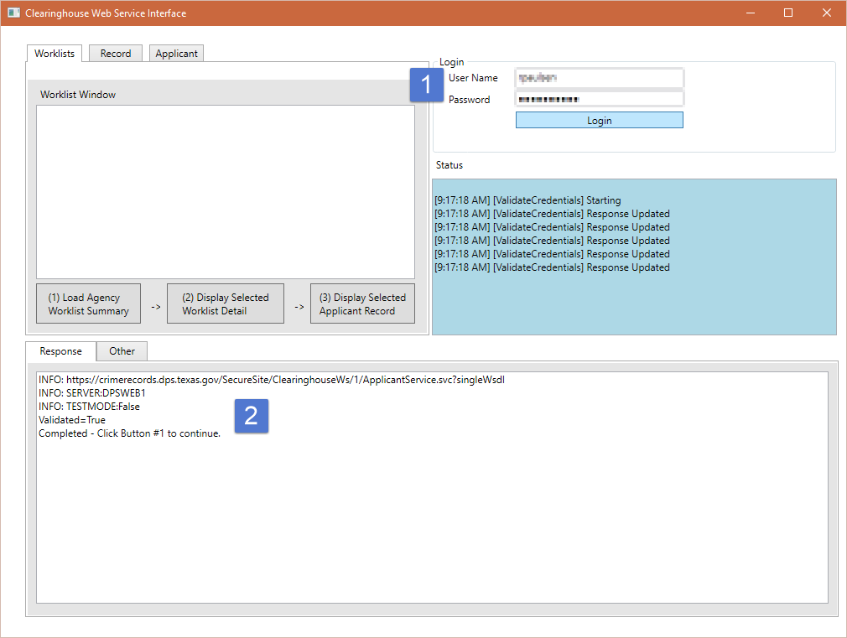

STEP 1 – View Worklist Summary
- Confirm you have the User Name/Password inputs populated
- Click Button (1) to load the worklist summary
- Review the worklist information.
- Select a worklist before continuing to STEP2
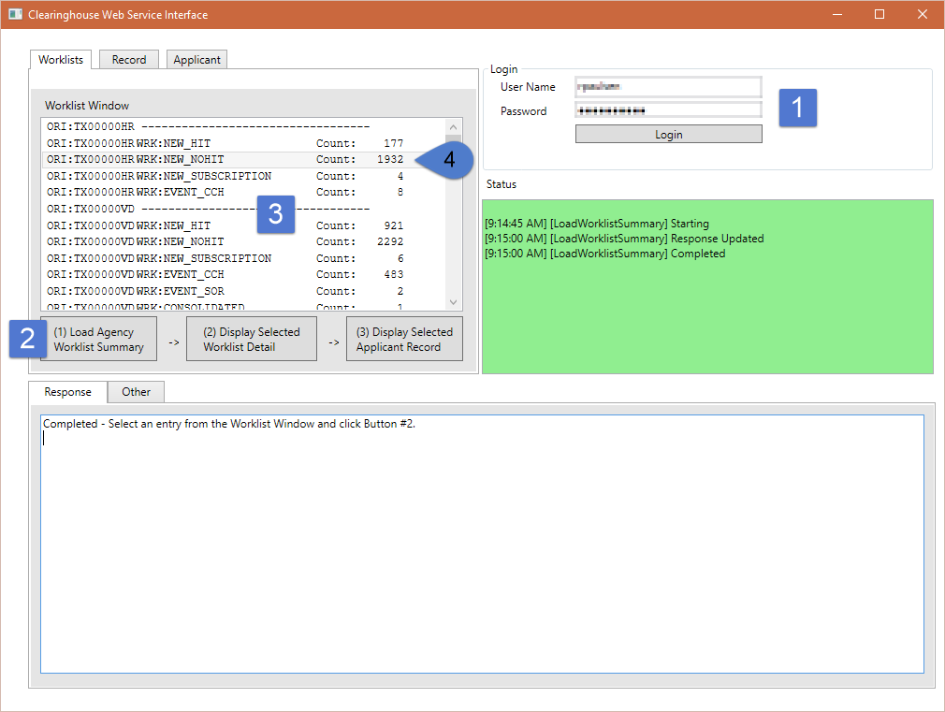

STEP 2 – View Worklist Detail
- Complete STEP1
- Click Button (2) to display details of the worklist selected in STEP1
- Select an applicant before continuing to STEP3
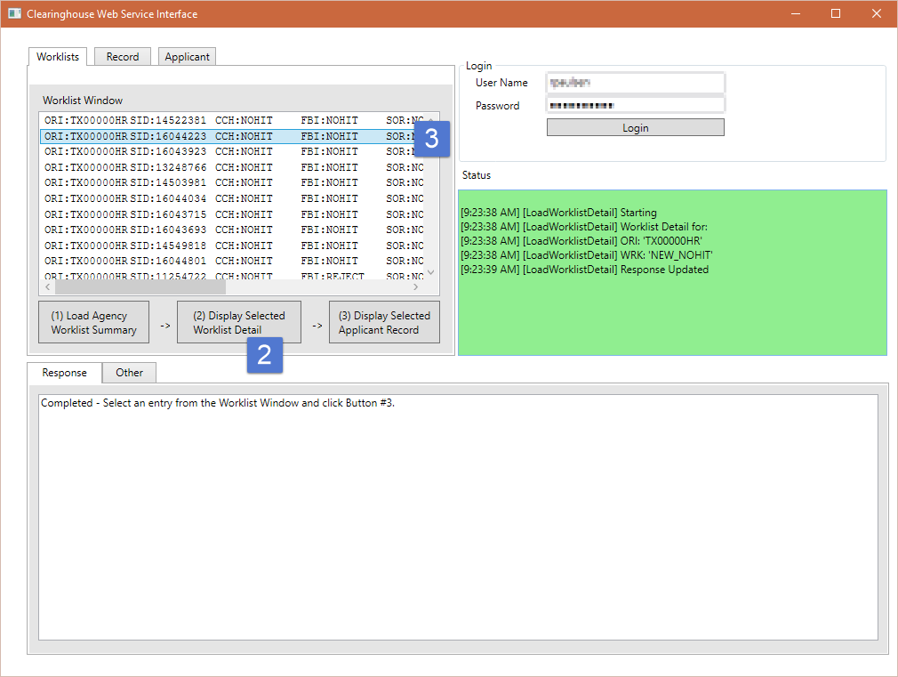

STEP 3 – View Applicant Record
- Confirm you have completed STEP 1 and STEP 2
- Click Button (3) to display the selected applicant record
- Review the XML response.
TIP: You will want to use an XML editor to format/view the XML. You can save the response to a local file and name it with an extension of .XML. You can then view the file in your web browser.
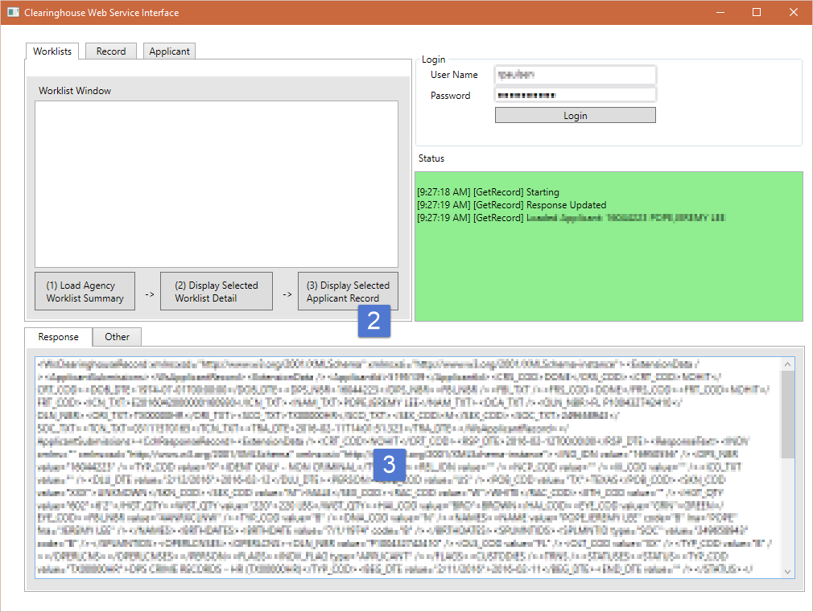

Appendix C – External References
In addition to the data returned by the web service, additional URLs may be utilized by an Agency’s application.
NOTE: The XML Name Spaces (xmlns) within the service methods *are not* considered an external reference, as these are only for identification purposes. Example of an xmlns:
<element xmlns="http://crimerecords.dps.texas.gov/2015/01/Clearinghouse" />

Embedded Data
Certain URLs are included within the XML returned by the service. These URLs are:
- The CCH Response’s link to the public Sex Offender Registry
https://publicsite.dps.texas.gov/SexOffender/PublicSite/Application/Search/Individual.aspx

External Resources for Rendering
Agencies may have been supplied XSLT files used for rendering XML returned from the web service as HTML. This includes CCH and FBI XML responses as HTML.
Although the HTML rendered by the XSLT’s do not specifically reference CSS documents, the rendered HTML expects to be displayed using CSS files that are located on the DPS Secure Site. Agencies may choose to host these CSS files locally or reference the CSS files available on the DPS Secure Site. If directly referencing the files on the DPS Secure Site, this URL is considered an External Resource.
https://securesite.dps.texas.gov/Clearinghouse/template/Record.css

